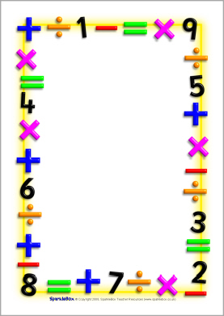
To Mrs. Smith
Who taught me Math isn’t just numbers
They’re motivation.
She wasn’t only a teacher but a friend too,
The teacher who toke her time to solve a simple problem
With a smile on her face.
The only one who understood me when
I was having a bad day,
Who showed me I’m worth more than I thought.
I’ll never forget the stories we shared,
And
Her “Happy Friday guys” with her little voice.
She made me feel like her favorite student
I hope that’s still true.
I say Thank you for who she was with me
And accepting me for who I am.
One day I’ll become a doctor so she can write to me too.
With deepest admiration and appreciation,
Olivia Garcia

